UK Lowland Wetland Habitats http://jncc.defra.gov.uk/page-1433

and UK Freshwater Habitats http://jncc.defra.gov.uk/page-1430
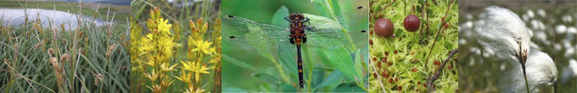

UK lowland wetland habitats include raised bog and fen. Lowland raised bog is a specialised habitat of elevated deposits of raised peat. Lowland fen is found across the whole of the British Isles, from sea level up into the hills, and grows on peat, peaty or mineral soils, which may be permanently, seasonally or periodically waterlogged. Fens are fed by groundwater and surface run-off and consequently support lush vegetation.
Lowland wetland habitats are a priority for nature conservation. They support a myriad of highly specialised plants and animals and have undergone a dramatic decline in area during the last century – consequently they are amongst the rarest and most threatened habitats in the UK. Both lowland raised bogs and lowland fen are included as priority habitats within the UK Biodiversity Action Plan,
The UK supports a diverse range of freshwater habitats. These are divided into running waters (rivers and streams), and standing waters (lakes and ponds).
- Running waters vary from torrential mountain streams to meandering lowland rivers. They are highly dynamic features, being heavily influenced by erosion, sedimentation and water flows. Their make-up is strongly influenced by topography, the chemical composition of the water, and the soils and land-use found in the surrounding catchment. They provide a wide range of specialized micro-habitats, and support many types of aquatic plants and animals. Marginal and bankside vegetation contribute to the biodiversity associated with watercourses. Rivers and streams link fragmented habitats in intensively farmed areas.

- Standing waters also show great variation. They range from larger lakes and reservoirs to small ponds, and from clear upland lakes to nutrient-rich lowland water bodies. There are specialized standing waters with brackish-water, and turloughs and temporary meres and ponds that are only filled with water for part of the year. As with running waters, their make-up is also strongly influenced by their nutrient status and surrounding catchment. They can change in composition due to natural factors or man-made pollution. Standing waters support a rich-array of aquatic life, including various species of amphibians, dragonflies and fish.
Freshwater habitats are a priority for nature conservation. They are home to an enormous variety of highly specialised plants and animals, and include some of the most natural, appealing and threatened habitat types in the UK.
More on Aquifer fed fluctuating water bodies, Ponds and Rivers:
Aquifer-fed naturally fluctuating water bodies
This habitat is associated with very large fluctuations in water-level. This includes a period when sites are completely, or almost completely, dry. There is no inflow or outflow stream at the surface, except at times of very high water level, when temporary outflows may occur. Instead, these water bodies are directly filled by an underlying aquifer (through the groundwater system), which is periodically emptied and recharged. All have hard water because the underlying rock is calcareous.
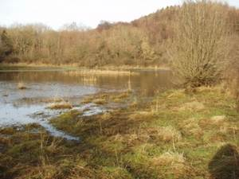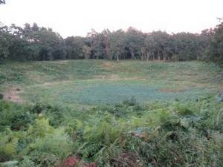
Aquifer-fed water bodies are a very rare habitat type, both in the UK and internationally. They occur in two forms:
- Turloughs – these are found over Carboniferous limestone in Northern Ireland and Wales
- Fluctuating meres – six fluctuating meres have been identified over chalk bedrock in the Norfolk Breckland; these have a complex pattern of emptying and refilling, sometimes with a stretch of several years during which the mere may remain dry, followed by a prolonged period when water is constantly present.
The vegetation of this habitat usually has a distinct zonation determined by water depth and frequency and duration of filling. When in their dry phase, their basins are normally partly or completely occupied by grassland, often with silverweed Potentilla anserina abundant. Turloughs in Northern Ireland retain some permanent swampy pools. A common element is the prevalence of aquatic and semi-aquatic mosses, such as Fontinalis antipyretica and Cinclidotus fontinaloides, which are more resistant to desiccation.
Fish are generally absent, but a range of amphibians can be found, including the great crested newt Triturus cristatus in the Breckland. Invertebrates include many insect species, such as dragonflies, water boatmen and diving beetles. Typically there is also a rich assemblage of micro-crustaceans, such as water fleas, which have resting stages that can remain viable in the soil during dry phases.

Ponds
Ponds form small water bodies that can be permanently or seasonally (temporarily) filled with water. They are very widespread, occurring in both rural and urban settings.
Ponds support an array of freshwater life:
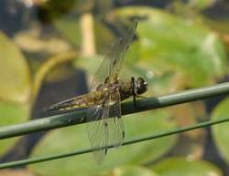
- plant species range from those in deeper water, to those in marginal areas and the draw-down zone
- ponds are particularly important for aquatic invertebrates, including damselflies, dragonflies, beetles, caddisflies, snails, water boatman and water scorpions
- amphibious newts, frogs and toads use them for breeding
- grass snakes, water voles and certain bat species use them as feeding areas
- waterbirds, such as moorhen, teal, redshank and snipe, use ponds for feeding, nesting and/or refuge

Rivers
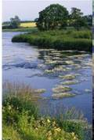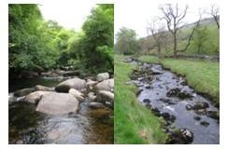
River habitats encompass all natural and near-natural running waters in the UK, i.e. with features and processes that resemble those in 'natural' systems. Numerous factors influence their ecological characteristics. These include:
- catchment features (geology, soil, vegetation, etc)
- topography
- gradient and flow rate
- altitude
- channel profile
- climate
- land use and other human activities
There are many different types of river, for example:
- slow-flowing meandering rivers in the lowlands (see right)
- fast-flowing headwater streams associated with the uplands (see right)
- chalk and limestone rivers
- rivers with strongly acidic, nutrient-poor waters
Rivers change greatly in character from their source, through their headwaters, and downstream to the sea or a lake. Specialized habitat features associated with rivers include rapids and riffles, in-stream rocky substrates, exposed shingle banks, scour pools, and gravel beds.
Rivers are home to many species of wildlife . These includes plants, such as water-crowfoot, water-starwort, water-cress and water-milfoil. Many species of fish use river habitats, including Atlantic salmon, brook lamprey, brown trout, bullhead, eel, perch and pike. Other well-known species include otter, water vole, and birds like dipper and kingfisher. A great number of invertebrate species are found in riverine habitats, including aquatic beetles, caddisflies, damselflies, dragonflies, mayflies and stoneflies.

