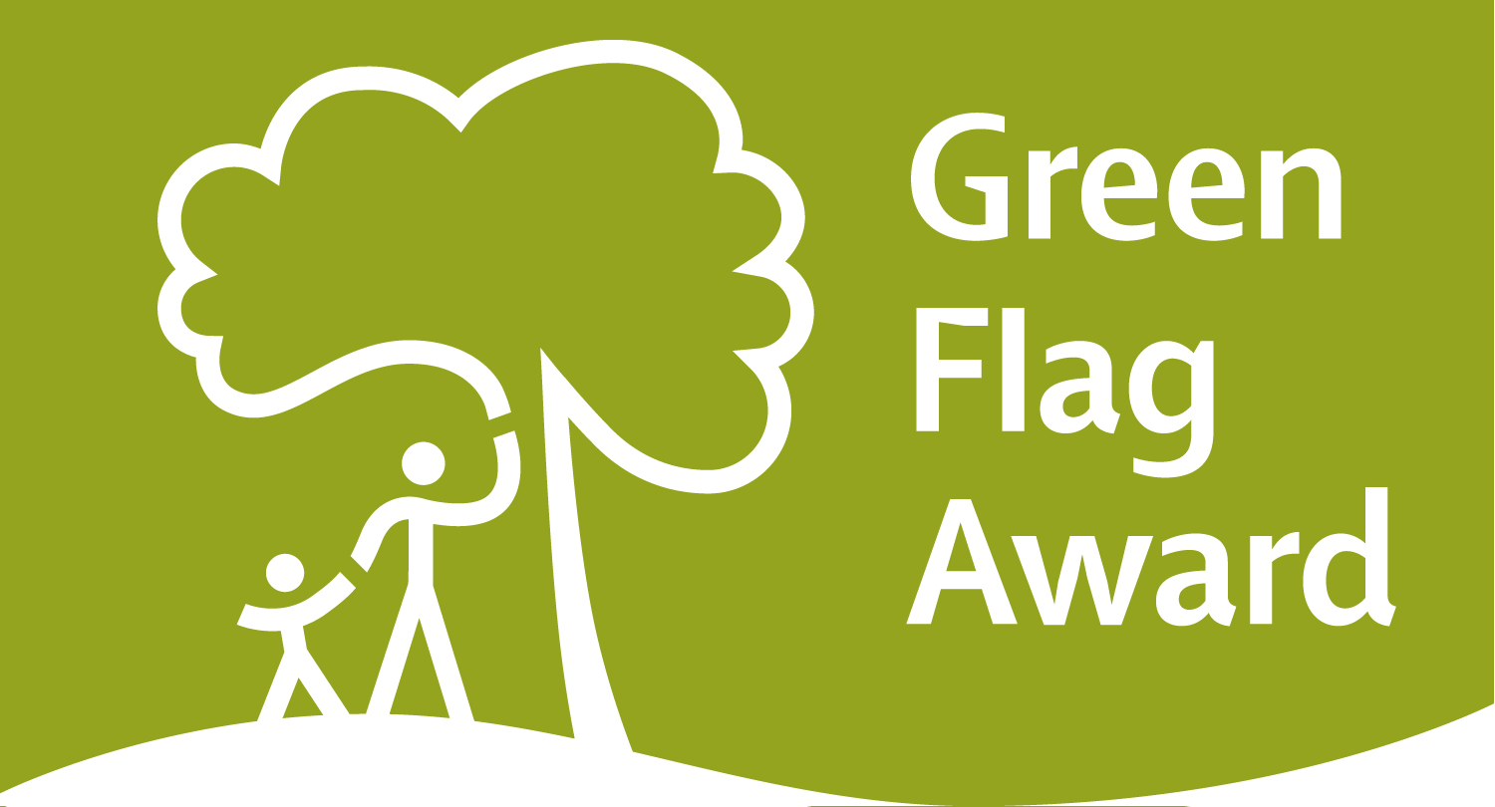

The Green Flag Awards are part of the movement to enhance and maintain the quality of public parks. The award schemes, of which there are several, Green Flag being the most well known and high profile of them, are currently run by Keep Britain Tidy.

The award of a Green Flag is still values by municipal parks departments and Basingstoke Environmental Care take the maintenance of its 2 central parks ( Eastrop Park and War Memorial Park) to Green Flag standards very seriously.

Parks are assessed for these awards by qualified personnel from within the industry, but the evaluation criteria and scoring system are published documents which anyone can use to evaluate their local public green space.

The following notes explain the evaluation criteria and scoring system - see how your neighbourhood park measures up.

Eight key criteria

1. A welcoming place
When approaching or entering the park/green space, the overall impression for any member of the community - regardless of the purpose of their visit - should be positive and inviting. There should be:
• Good and safe access
• Good signage to and in the park/green space
• Equal access for all members of the community

2. Healthy, safe and secure

The park/green space must be a healthy, safe and secure place for all members of the community to use. Any issues that have come to light must be addressed in the management plan and implemented on the ground. New issues that arise must be addressed promptly and appropriately.
• Equipment and facilities must be safe to use
• It must be a secure place for all members of the community to use or traverse
• Dog fouling must be adequately addressed
• Health and safety policies should be in place, in practice and regularly reviewed
• Toilets, drinking water, first aid, public telephones and emergency equipment where relevant (e.g. life belts by water) should be available in or near the park/green space, and be clearly signposted.

3. Clean and well maintained
For aesthetic as well as health and safety reasons, issues of cleanliness and maintenance must be adequately addressed, in particular:
• Litter and other waste management
• The maintenance of grounds, buildings, equipment and other features
• A policy on litter, vandalism and maintenance should be in place, in practice and regularly reviewed.

4. Sustainability
Methods used in maintaining the park/green space and its facilities should be environmentally sound, relying on best practices available according to current knowledge. Management should be aware of the range of techniques available to them, and demonstrate that informed choices have been made and are regularly reviewed. Parks/green spaces should:
• Have an environmental policy or charter and management strategy in place, which is in practice and regularly reviewed
• Minimise and justify pesticide use
• Eliminate horticultural peat use
• Recycle waste plant material
• Demonstrate high horticultural and arboricultural standards
• Have energy conservation, pollution reduction, waste recycling, and resource conservation measures

5. Conservation and heritage
Particular attention should be paid to the conservation and appropriate management of:
• Natural features, wildlife and fauna
• Landscapes
• Buildings and structural features
• These should serve their function well without placing undue pressure on the surrounding environment

6. Community involvement
The park/green space management should actively pursue the involvement of members of the community who represent as many park/green space user groups as possible. The following should be demonstrated:
• Knowledge of user community and levels and patterns of use
• Evidence of community involvement in management and/or developments and results achieved
• Appropriate levels of provision of recreational facilities for all sectors of the community

7. Marketing
• A marketing strategy should be in place, which is in practice and regularly reviewed
• There should be good provision of information to users, e.g. about management strategies, activities, features, ways to get involved
• The park/green space should be promoted as a community resource

8. Management
• A management plan or strategy should be in place
• This should clearly and adequately address all of the above criteria and any other relevant aspects of the park/green space's management
• The plan must be actively implemented and regularly reviewed
• A financially sound management of the park/green space must also be demonstrated
Green Flag Award Score Sheet

Scoring line

0 1 | 2 3 4 | 5 6 | 7 | 8 | 9 | 10
Very Poor | Poor | Fair | Good | Very Good | Excellent | Exceptional

Name of green space

Managing authority

Judge(s)

Date of desk assessment

Date of field assessment

Scoring

- Each category must be scored out of 10
- Work out the average score for desk assessment and multiply by 3 (score out of 30)
- Work out the average for field assessment and multiple by 7 (score out of 70)
- By adding the two scores together you will get a final mark
- For a site to pass each section they must reach a minimum of 15 on the desk assessment and 42 on the field assessment.
- An overall score of 66 must be scored for a site to achieve Green Flag Award status
- Rounding up or down of numbers must be done at the very end of each assessment, when you multiply the average.

Strengths & recommendations

- Comments and recommendations must be included against each category in the feedback sections. They should be detailed enough to provide constructive information to applicants

Final score

Desk assessment (minimum 15) |  | Field assessment (minimum 42)
Total score |  | Green Flag Awarded?

Field Assessment

A Welcoming Place | Score |  | Conservation and Heritage | Score
1 Welcoming |  |  | 19 Conservation of natural features, wild fauna, flora
2 Good and safe access |  |  | 20 Conservation of landscape features
3 Signage |  |  | 21 Conservation of buildings & structures
4 Equal access for all

 |  |  | Community Involvement
Healthy, Safe and Secure |  |  | 22 Community involvement in management & development
5 Safe equipment & facilities |  |  | 23 Appropriate provision for community
6 Personal security in park

7 Dog Fouling |  |  | Marketing
8 Appropriate provision of facilities |  |  | 24 Marketing & promotion
9 Quality of facilities |  |  | 25 Provision of appropriate information
 |  |  | 26 Provision of appropriate educational/information
Clean and Well Maintained

10 Litter & waste management |  |  | Management
11 Grounds maintenance and horticulture |  |  | 27 Implementation of management plan
12 Building & infrastructure maintenance

13 Equipment maintenance |  |  | Total
 |  |  | Average (total divided by 27)
Sustainability |  |  | Out of 70 (average x 7)
14 Environmental sustainability –
Energy & natural resource
conservation, pollution

15 Pesticide use

16 Peat use

17 Waste minimisation

18 Arboriculture & woodland management

Desk Assessment (Management Plan and supporting documentation)

 | Score |  |  | Score
1 Presentation |  |  | 7 Community Involvement
2 Health, Safety & Security |  |  | 8 Marketing Strategy
3 Maintenance of equipment, buildings & landscape |  |  | 9 Overall management
4 Litter, cleanliness, vandalism |  |  | Total
5 Environmental Sustainability |  |  | Average (divide by 9)
6 Conservation of heritage & nature |  |  | Out of 30 (average x 3)

Green Flag Award 2015/2016 Assessment Feedback

Name of Site –
Managing Organisation –

Bandscores

Desk Assessment | 0-9 | 10-14 | 15-19 | 20-24 | 25-30
Field Assessment | 20-29 | 30-39 | 40-44 | 45-49 | 50-54 | 55-59 | 60-64 | 65-70
Overall  score | 30-44 | 45-54 | 55-59 | 60-65 | 66-69 | 70-74 | 75-79 | 80+

Status –
Overall band score –

Desk Assessment Feedback (Management Plan and supporting documentation)

Band score –

Criteria | Strengths | Recommendations
Presentation

Health, Safety & Security

Maintenance of equipment, buildings
& landscape

Litter, cleanliness, vandalism

Environmental Sustainability

Conservation of
heritage & nature

Community
Involvement

Marketing Strategy

Overall management

Additional comments
.

Field Assessment Feedback
Band score –

Criteria | Strengths | Recommendations
A Welcoming Place

Healthy, Safe
and Secure

Clean and
Well Maintained

Sustainability

Conservation
and Heritage

Community
Involvement

Marketing

Management

Additional Comments

