**Enhancement and Management of Grasslands**

**Flora Locale workshop SE2 – 19/6/2014 held at the Stables, Free Street, Bishop’s Waltham**

**Tutor: Pete Potts (25 years with HCC Countryside Services creating and managing various meadow projects )**

This was a much better course than the Flora Local grassland course at Leighton Moss, Lancashire which visited one NNR site on which the course tutor had little personal experience.

Here we visited a variety of sites, in which the tutor had either been project leader or had been

involved. All the sites visited were owned either by HCC or the local Parish. Most sites were grazed at least once a year. Most of the sites had some status, NNR, LNR, SSSI or SINC. The exception to this was Hoe Cemetery which had a hay cut once a year using volunteers.

**Key Points**

• Grazing is better that Cut & Clear

• Some grazed sites will also need cut & clear

• Ensure the site to be “treated” is as weed free as possible

• If site is weed free and has fine grasses, cut & clear in early autumn and just seed

• If site is weed free and has mixed grasses, cut & clear in early autumn and disc harrow

before seeding

• If site is weed free but has course grasses, in late summer cut & clear, a week later, spray

and seed soon after (2-3 weeks)

• If sites have a few weeds, these can be sprayed off a week before the cut & clear

• Both these non-intervention strategies may benefit from a light harrow or surface scuffing to open up the thatch before seeding

• Disturb the ground as little as possible as this brings up weed seeds (Scuffing and disc

harrowing do not turn over the ground)

• Cut & Clear on a “clean” (i.e. weed free) site can generate saleable hay (Needs a baler

attachment)

• Some flora species can tolerate regular grass cutting, e.g Bird’s-foot Trefoil, Lady’s

Bedstraw, etc.

**Sites at Bishops Waltham**



**Site 1 – Dundridge Nature Reserve** was an HCC/Community purchase and was meadow that had been restored about 10 years previous with local funding. There was only enough money to seed a 10 m strip at the eastern end of field but over the years the Yellow Rattle had spread with other species following. The technique they used for cut & clear, was like hay making. Cut, leave to dry, then turn the arisings over with a rotary rake and finally bale or clear. It’s the rotary rake that can distribute seed to other parts of the site as the hay is turned over. The original field was divided into two by a planted hedge, which after 10 years is maturing nicely.

**Site 2 – Also on Dundridge Nature Reserve** – this was scraped and reseeded when they had

access to a digger. While the seeded meadow area was fine, there was also a margin of nettles

that they had sprayed and seeded with Red Campion, Hedge Bedstraw and Bluebells. There were

a few patches of RC and nothing else with the nettles still advancing! Also no sign of Bluebells, but

they take 7 years or more to develop from seed.

**Site 3 – Hoe Cemetery owned by the parish**. A number of small patches of meadow were

developed by cutting and just seeding into the sward. All sites were weed free and had been used

to regular cut & leave. Where the edge of meadow met the tarmac of the car park, the grass had

been cut in strip about a foot wide. This gave the impression that the site was maintained and the

meadow was meant to be there and was managed regularly.

HCC CS have BCS equipment and which they use to manage the cemetery. They scythe cut the

grass and herbs, use the rotary harrow to turn the arrisings and have a mini baler to pick up and

handle the resultant hay. They then sell the hay bales to local riding establishments and/or Marwell

Zoo.

**Site 4** was an LNR only briefly visited.

.

**Site 5 – The Moors,** an LNR but it was part of large SSSI that covered the headwaters of the river

Hamble. The meadow was rubbish but the SSSI rules prevented HCC from any more intervention.

They had tried to improve the herb content of this meadow using English Nature’s advice of cut &

clear and harrowing before seeding, but the experiment was a failure. It had just been grazed and

there appeared to be a goodly quantity of course grasses with little flora diversity. (Thinking about

this in relation to KCG sites, perhaps it would have been better to spray off after the cut & clear but

before they re-seeded, but being a SSSI site they would have been prevented from spraying?!)

An interesting feature of site were the “Sand Boils”. These were natural springs on a sand

substrate. The water was coming out with such pressure that the surface looked as if it was boiling.

When the artesian pressure is high, such as last winter, these springs can form small fountains! As

the water is coming out at a constant 10°C, on fros ty mornings, the springs generate vapour that

again looks as if the water is boiling!

An aside on SSSI’s – The Hamble headwaters SSSI was defined in the 50’s as a desk exercise.

Consequently there were good areas that were outside the SSSI while the rubbish meadow was

part of the designated area!

**Site 6 – Bishop’s Palace managed by English Heritage**, a current project for Pete. EH want to

increase the herb content of the grassed areas around the site. The topology provides a number of

opportunities in the form of banks and slopes that discourage footfall. These could easily be

improved by cut & clear, optional spraying and reseeding. The quality of the underlying grass is

pretty good with few weeds. This site, like the cemetery, is not suitable for grazing.

**Site 7 – Claylands LNR**, a disused clay pit that waa taken over by HCC about five years ago.

Originally “waste” land used for informal motorcycle scrambling. The site was fenced and access

restricted to keep the bikes out and the cattle in. Site consists of steep banks but also includes a

field that has been divided by a planted hedge. We were first shown an adjacent field that was still

used for two cuts of silage, which was devoid of herb diversity. Contrast this with the adjacent

fields on identical land that had been subsequently converted to meadow. The meadows supported

impressive quantities of common spotted orchid and the occasional pyramidal. Actually the steep

banks also supported these orchids.

As part of the welcome pack, Pete also included four advice notes from Flora Locale:

• Enhancing the floral diversity of semi-improved grassland

• Sowing wild flora seed

• Spreading hay

* Managing newly created grassland.

As I do not have good reproductions of these leaflets their text content is reproduced below:



Semi-improved grassland contains a reasonable variety of fine-leaved grasses, such as Red Fescue, Common Bent, Meadow Foxtail, Sweet Vernal-grass and Crested Dog’s-tail.

There may be some herbs present, such as Buttercups, Dandelions and Common Sorrel. However ,herbs will be scarce if the sward has been treated with a broad leaved herbicide or artificial fertilizer in the past.

Damper grassland may also contain patches of rush, sedge and Tufted Hair-grass

**Grasslands with a high proportion of False-oat Grass,**

**Cocksfoot, Yorkshire Fog, Perennial Rye-grass and**

**White Clover are unsuitable for floral enhancement using**

**the methods described in this note.**



Herb-poor amenity grassland prepared for inoculation with wild meadow seed. Strips were knapsack sprayed with Glyphosate.

Patch- and Strip-spraying and seeding

The flora of the site should be surveyed between May and June ( when grass and herbs will be in flower). As the existing sward already has some species deiversity the aim should be to retain this as far as possible. The botanical survey will identify areas where introduction of seed could be beneficial and identify the target community to be restored, but may also suggest that the sward could be restored without seed introduction. If green hay is to be used, ground preparation should be completedin July ( prior to the hay cut) If processed seed is to be used, the site should be readu to sow by the end of August or in earlt September.

The above illustration is of the Patch- or Strip-spraying method using no soil disturbance. The method involves no soil cultivation so minimizes nitrate leaching and disturbance that could lead to a flush of pernicious weeds. It can be done using equipment readily available on the farm., and is an ‘innoculation’ technique that does not require a large quantity of seed so is cost effective if seed has to be purchased.

Seed will be sown or green hay or forage seed strewn over killed areas of the sward.

Herbicide should be applied to the sward where there is sufficient leaf area to absorb the chemical but not on tall or tussocky grassland or if thick grass mats are present. Prior to spraying the sward should be grazed or mown, and harrowed if there are any grass mats. Areas should be chosen to Patch- or Strip-spray with a total-kill herbicide. The total area killed should not exceed 30% of the site and the patches should be well distributed about the field.

After the grass has been killed and Appropriate seed mix containing Yellow Rattle shuld be spead over the killed patches b y hand using a spinner or by drilling seed onto the surface. Additional Yellow Rattle can be broadcast into te untreated areas of grass. Wild seed should not be buried as it requires light to germinate. Treated areas should be sown at the rate of 10 – 20Kg/hectare ( 1 – 2 g/m2.

Whole Field Treatment using mechanical treatment methods

**This method is not suitable for land which has a history of Dock or Creeping Thistle infestation or for highly improved sward that has been repeatedly fertilized.**

Create 30 – 50% bare ground before sowing by power harrowing or disk harrowing.

Using a sowing rate of 10 – 20Kg/hectare broadcast the seed across the whole site.

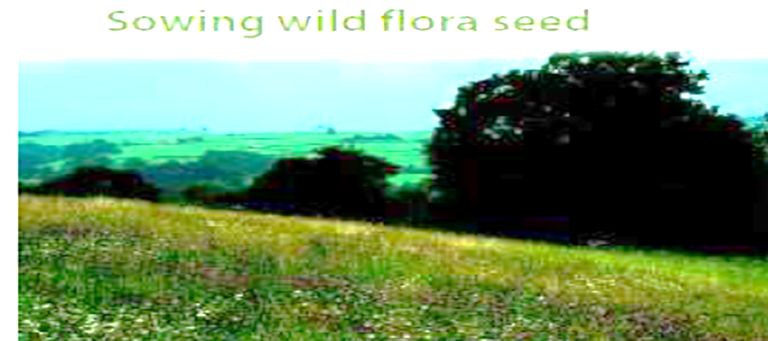

**Sowing depth**

Seed should be broadcast or drilled on the soil surface. It should not be buried by slot seeding because all wild seed requires light to germinate. Burying seed only a few millimetres may significantly reduce germination rates.

**When to sow**

The ideal time for sowing wildflower seed is late summer ( August - mid-September) it is possible to sow in mid - late July but drought at this time can lead to some loss if germination has started.

Seed germinating late in Autumn may be frost damaged.

Spring sowing is not recommended except for areas prone to winter flooding or where rain may wash seed away. Spring sowing may also be prone to spring/early summer drought.



**Using Green Hay**

This technique can be used where a species rich donor site is less than 2 miles away from the receptor site.

The receptor site must be ready prior to the donor site being cut – by mid-July for lowland sites. All steps must be carried out on the same day although the mown grass can be left in situ for one day before picking up to reduce its weight and bulk. but this may lead to the loss of some Yellow Rattle and other seeds - which are very ripe at the time of harvest.

Mow the hay when the main grasses such as Red Fescue, Meadow barley and Meadow foxtail hold ripe seed and the Yellow Rattle seed is still on the plant ( mid-July for Southern-central England or late July-August for upland Britain).

- Use a mower without a ? to mow the grass

- Rake the mown grass into lines/swathes depending on the machinery

- Pick up and make into up to 6 round bales at a time

- Cart the bales to receptor site

- Load each bales into the straw chopper and spread across the receptor field in a ratio of 1:2 – 1.3 receptor hectares to donor hectares.

- Do not leave theh ay in bales for more than 1 hour to avoid heating up and the seed deteriorating,

- Flailing the spread hat is optional,

- Late flowering species, such as Ladies bedstraw, will need to be collected separately by hand and sown separately.

These techniques can be scaled down for smaller sites and smaller scale machinery. Pedestrian machinery can be used to harvest species rich green hay from roadside verges, churchyards, in which case the hay must be spread thinly and not left in heaps on the receptor site.

**Using Dry Hay bales**

Spreading Hay from dry hay bales has been used successfully to create and restore wildflower grassland in Dartmoor National Park. The seed content and diversity will vary and may be low as seed will have dropped out while the hay was dried, turned and baled.



Many wild flowers and grasses take up to 3 years to flower. Correct management of the grassland is essential in these early years. Regular checking and action to remedy any weed problems. Cutting or grazing must be managed to allow the developeing sward to become properly established. Slippage in weed control is often a problem where where labour and machinery are not always close to hand. **Management must be flexible and reponsive to the individual site**

Yellow Rattle and annual weeds in May after a late Autumn seeding with chalk grassland wild flower mix.

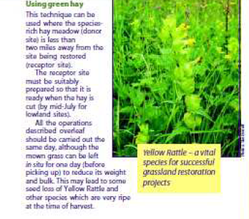

**Managing Weeds**

On ex-arable areas there will be a strong growth of low growing annual weeds from the seed bank and Yellow Rattle in the first growing season. Other sown plants will germinate in late Spring and early summer and will benefit from the shelter provided by low growing annual weeds such as Groundsel and Field pansy which do not need to be removed.

The vegetation will need to be topped in the first spring and summer, probably several times, to prevent growth of tall weeds including Creeping thistle, Broad leaved dock, Spear thistle and Sow thistle. Topping in mid- late June is particularly important to prevent Spear thistle flowering. This species can be prolific in ex-arable sites in the first few years.

As a biennial species it will die out fairly quickly if flower head seeding is prevented - late autumn topping will also be necessary as it will flower again at that time.

To prevent harm to ground nesting birds and young hares, topping height between April and early July should be no lower than 20 cms.

Other Weeds Act plants can be individually removed using a Lazy Dog tool although this is a labour intensive exercise. Spot spraying using a knapsack with a suitable herbicide is an alternative option for non-organic sites. Weed-wiping is only advised where there is a serious perennial weed infestation in subsequent years – the sward must be Spring-grazed prior to treatment. Ragwort will need to be pulled or spot sprayed.

**Grazing & Mowing for floral diversity**

Year 1 – the sward should be lightly grazed or mown in early July. Large quantities of mown material should be removed - developing seedlings will die if smothered by cuttings.

Year 2 – ideally the sward should be left undisturbed between mid-Feb and late-July.

However, some topping during this time may be required to manage patches of weed. This approach is best used in early years as it will allow sown plants to flower, set seed and spread. Between late-July and mid-August the sward should be mown for hay or topped prior to ‘aftermath’ growing until the end of the growing season.

In the early years , to achieve maximum floral diversity can be specified as:

* Sward height at the beginning of the growing season must not exceed5cms (3cms is preferable)
* A high proportion of sown grass and wild flowers allowed to flower and set seed before mowing and grazing in mid-Summer and
* Scarcity of creeping thistle, Welted thistle, Spear Thistle and Broadleaf Doc by year 5.

Once the sward has become established, the grazing and mowing requirements will need to be reviewed, taking into account the characteristics, condition and growth. Aftermath and late-summer grazing will be essential for hay meadows and many other sites.

